**Parent Account Errors:**

Schoology is currently pulling in parent emails to student accounts, which is creating an error message for some parents when creating their account. The district is aware of this issue and working with Schoology to fix the problem. An immediate fix would be to use an email account that is not associated with either HAC or registration at the school. We are sorry for any frustration this has caused and are working with Schoology to correct the issue.

**Notification Settings:**

Click [here](https://support.schoology.com/hc/en-us/articles/201000803-Personal-Account-Parent-Notifications) for the help section in Schoology for notification setting changes. There is a notification setting (like on Facebook) where students, teachers, and parents can change the setting to NOT receive notifications.

Under your account name is the drop down menu for notifications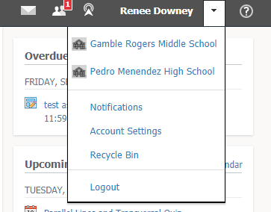

Here are the default settings (change using the right hand side drop down menu):

