Welcome to Bus Planner Web Parent Portal

- Using the same website as you would for work log in but use the parent portal
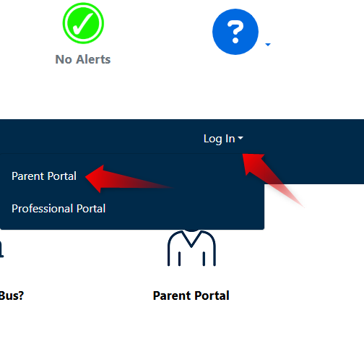
- Click create account. Using the email address that you use for your children and fill in all the questions

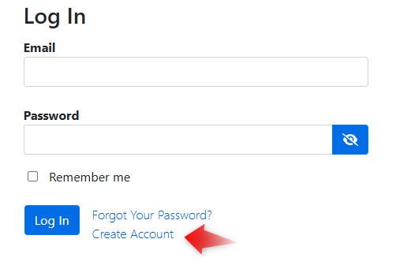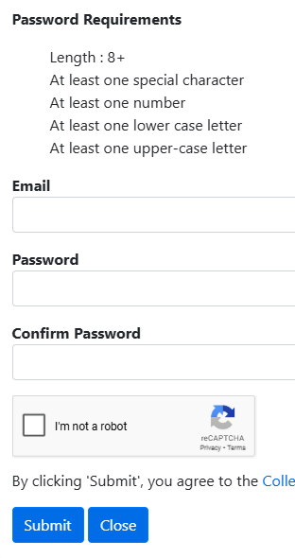
- In this section you can see your child’s bus information
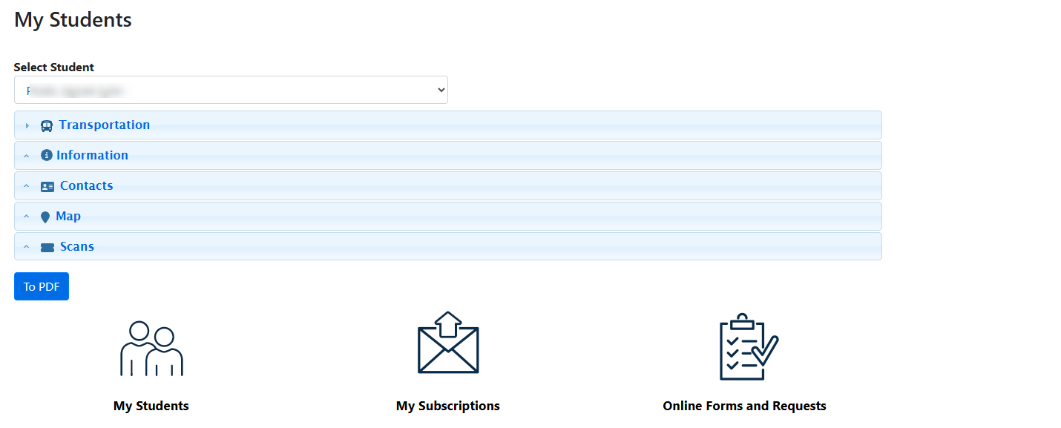
- This will give you access only to the students who are associated with your email that you sign up with.

If you have any questions or need further assistance please reach out to Tiffany Bravo at Transportation Office: 904-547-8076

